LOGISTICS DATA ANALYST INTERNSHIP

WEEK 4 REPORT
Predictive Modeling and Optimization in Logistics Systems

Prepared by: [S.R. Reshmi]
Dataset: Hypothetical logistics data

1. Abstract
This report demonstrates a supervised machine-learning workflow for predicting shipment delivery time and using the predictions to support logistics planning. A hypothetical dataset of 300 shipments is used. Linear Regression and Random Forest Regression are trained and compared using a held-out test set, MAE, RMSE, R-squared, and five-fold cross-validation. The report also discusses scenario-based operational improvements, limitations, and recommendations. All records are simulated for learning and do not represent real company performance.

2. Problem Definition and Objectives
Late deliveries can disrupt customers, inventory availability, and transport planning. The problem addressed in this task is: given information available when a shipment is planned, estimate its delivery time in days. The predicted time can help planners identify shipments that may need attention, set realistic expectations, and consider alternative operational arrangements. Objectives are to define the target and features, prepare data, train two regression models, compare performance, validate the results, and propose practical optimization strategies.

3. Dataset and Features
The dataset contains 300 simulated shipment records. The target variable is Delivery_Time_Days. Input features are Distance_km, Shipment_Weight_kg, Transport_Mode, Traffic_Level, Weather, and Region. The CSV also contains Shipment_ID, Transport_Cost_USD, and a simple delay-risk label for contextual exploration. The cost and risk label are not used as predictors in this model. The synthetic data is generated with illustrative relationships so the code can be practiced without personal or business data.
Feature | Meaning | Type
Distance_km | Estimated route distance in kilometres | Numeric
Shipment_Weight_kg | Shipment weight in kilograms | Numeric
Transport_Mode | Road, Rail, or Air | Categorical
Traffic_Level | Low, Medium, or High | Categorical
Weather | Clear, Rain, or Storm | Categorical
Region | North, South, East, or West | Categorical
Delivery_Time_Days (target) | Observed/simulated time to deliver | Numeric target

4. Workflow
- Load the CSV dataset and inspect columns and missing values.
- Separate input features (X) from target variable (y).
- Split data into training (80%) and test (20%) sets.
- Impute missing numeric/category values and one-hot encode categories using a pipeline.
- Train Linear Regression and Random Forest Regression.
- Evaluate test predictions with MAE, RMSE, and R-squared.
- Use five-fold cross-validation on training data to check stability.
- Compare the models and discuss scenario-based optimization actions.

5. Model Selection

5.1 Linear Regression
Linear Regression is a simple baseline model that estimates a linear relationship between input features and delivery time. It is fast and relatively easy to explain, so it provides a useful reference point. However, it may not capture complex interactions or nonlinear patterns.

5.2 Random Forest Regression
Random Forest combines predictions from multiple decision trees. It can model nonlinear relationships and interactions among distance, transport mode, traffic, weather, and weight. It is less transparent than a simple linear model and may need tuning to avoid overfitting. In this report, both models are compared rather than assuming one is automatically better.

6. Data Preparation and Training
The numeric features are imputed with their median if missing values occur. Categorical features are imputed with their most frequent category and converted into indicator columns with one-hot encoding. The transformations are placed in a scikit-learn Pipeline so they are fitted on training folds rather than using information from the test set. The dataset is split into 80% training data and 20% test data using a fixed random seed for reproducibility.

Python code excerpt
X = df[features]
y = df["Delivery_Time_Days"]
X_train, X_test, y_train, y_test = train_test_split(
X, y, test_size=0.20, random_state=42
)
model.fit(X_train, y_train)
prediction = model.predict(X_test)

7. Evaluation Metrics
Metric | Meaning | How to interpret
MAE | Mean Absolute Error: average absolute prediction error | Lower is better; easy to read in days
RMSE | Root Mean Squared Error: gives larger errors more influence | Lower is better; useful when large mistakes matter
R-squared | Proportion of target variation explained relative to a mean baseline | Closer to 1 is generally better; can be negative on test data
5-fold CV MAE | Average MAE over five training-data folds | Helps assess stability across different training/validation splits
The test set is kept separate from training. Cross-validation is applied to the training set only. Metrics from a synthetic dataset demonstrate the workflow and must not be treated as proof that the model will perform equally well on real deliveries.

8. Model Evaluation Results
Model | Test MAE (days) | Test RMSE (days) | Test R² | 5-fold CV MAE (days)
Linear Regression | 0.283 | 0.337 | 0.914 | 0.290
Random Forest | 0.403 | 0.498 | 0.812 | 0.422
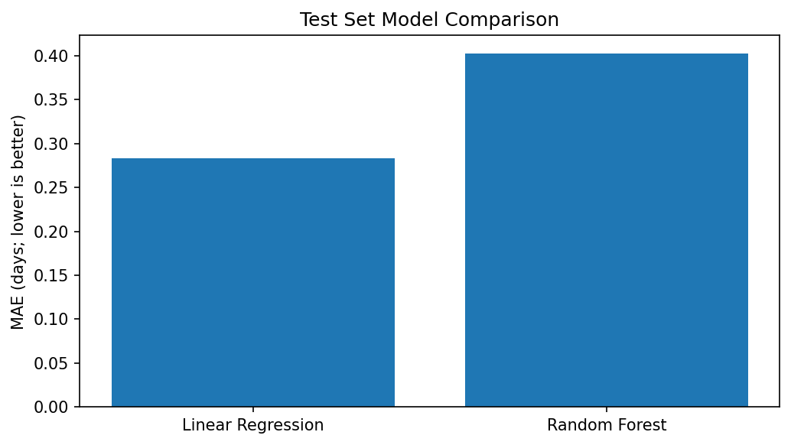
Interpretation: Based on test MAE in this run, Linear Regression has the lower average absolute prediction error. Check RMSE and cross-validation MAE alongside MAE before selecting a model. Because the data is simulated from a simplified pattern, this comparison is educational and should be repeated on real, time-relevant data.

9. Actual vs Predicted Values
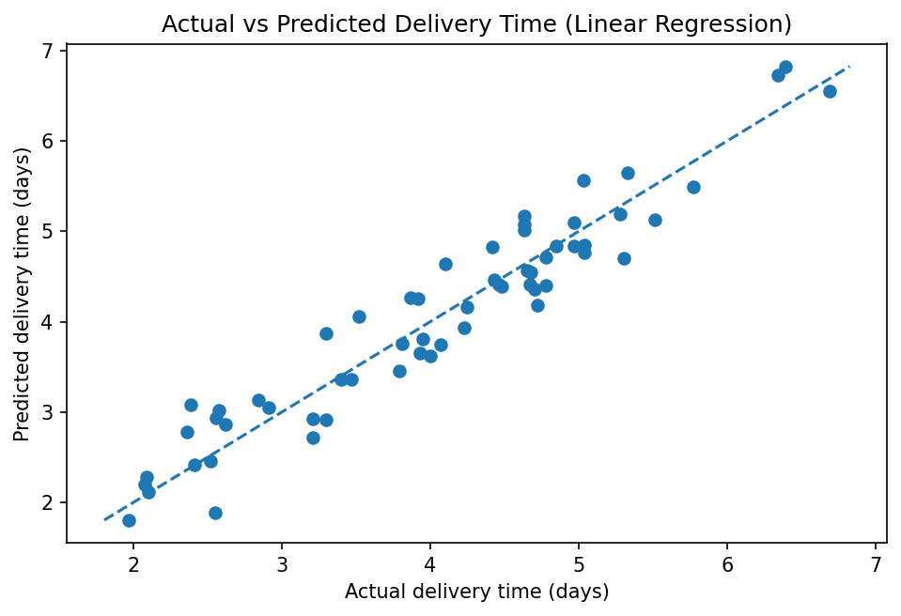
The scatter plot compares actual delivery times with predictions. Points close to the diagonal reference line represent more accurate predictions; points farther away indicate larger errors. A model should be checked for systematic under-prediction or over-prediction, especially for long-distance or adverse-weather shipments.

10. Optimization Strategies

Risk-based review
Use predicted delivery time together with the promised delivery deadline to flag shipments with little schedule buffer. Dispatchers can review these shipments earlier rather than waiting until they become late.

Route and mode planning
Compare feasible route or transport-mode scenarios using estimated time, cost, service requirements, and capacity. Do not choose the fastest option automatically; consider its additional cost and operational constraints.

Capacity and staffing
Use forecasted workload and likely delivery durations to plan dispatch windows, vehicle allocation, and staffing. Validate the approach with actual historical demand before implementation.

Exception management
Create a daily list of shipments predicted to exceed service targets. Investigate traffic, weather, address, warehouse, or handover issues and record the actual cause.

Continuous monitoring
Compare predicted and actual delivery times every week. Retrain only when enough new data is available and performance drift is demonstrated.

11. Scenario-Based What-If Analysis
The Python script predicts delivery time for three example scenarios using the selected model: a road shipment under low traffic and clear weather, the same road shipment under high traffic and rain, and an air shipment under low traffic and clear weather. This illustrates how planning conditions may change predicted delivery time. The output is a comparison tool, not a complete route optimizer. Real decisions must also consider cost, vehicle capacity, safety, service commitments, and route feasibility.

Python code excerpt
scenario = pd.DataFrame([
[250, 100, "Road", "Low", "Clear", "South"],
[250, 100, "Road", "High", "Rain", "South"],
[250, 100, "Air", "Low", "Clear", "South"],
], columns=features)
scenario["Predicted_Days"] = model.predict(scenario).round(2)

12. Limitations and Responsible Use
The dataset is synthetic, relatively small, and generated from an illustrative formula. Its metrics do not show how a model will perform for a real company. Real logistics data may contain missing values, changing traffic patterns, different seasonal effects, and unexpected events. Before deployment, collect representative historical data, compare against a simple baseline, evaluate errors across regions and transport modes, check for data leakage, and monitor model performance over time. Predictions should support human planning, not replace operational judgment.

13. Conclusion
This task demonstrates the full predictive modelling process: defining a target, preparing features, splitting data, training alternative regression models, evaluating test performance, applying cross-validation, and using predictions in what-if scenarios. The model can help identify shipments that deserve earlier attention, while optimization recommendations focus on route/mode review, resource planning, and exception management. The most important next step is to validate the workflow on real, documented shipment history before using it for business decisions.

